**Part 2: Design Alternatives**

**Project Description**

**Period** is an innovative application designed to address a critical need for women: access to free feminine hygiene products. The app serves as a convenient platform for women to locate nearby vending machines that dispense tampons and pads. By providing these essential products with the use of authentication, Period aims to empower women, promote menstrual health, and foster a more inclusive and supportive community. Whether in schools, workplaces, or public spaces, Period ensures that women have easy access to the hygiene products they need during their menstrual cycles.

**Key Requirements**

**Data Connection –** Entering period doesn’t require a lot of data, however scanning a PQ QR code is where you need at least data connection.

**Location –** As you know, Period is not limited to software as it has its own structural counterpart: the vending machine. And to be able to put the vending machine, we need locations to attach the said vending machine.

**Application Icon Size Comparison**

**     **

The icons above show the various sizes of Period. This is essential to identify which sizes will look in different applications such as phones, tablets, laptops, etc.

**Design**

The Period application wants to appeal to the users through a comfortable design. So, to showcase the design, we have to identify what the Color Palette, Font Style, and GUI is.

* **Color Palette**

**#FF9E9E**

**#DC659E**

**#F6D4E2**

**#FFFFFF**

**#ED8FB2**

**#D81E6D**

**#D81E6D**

**#E8B3B3**

**Color Palettes**

The chosen color palette is the main colors that would be seen in our application. We have chosen this color palette to promote femininity and the hues of pink usually signifies calm and peace.

* **Font Style**

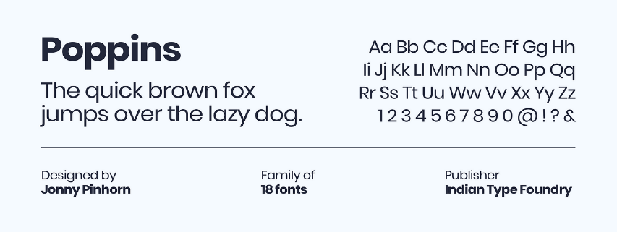Poppins is the font we have chosen because the style is pleasing to the eye, and its modern yet simple. Many applications, such as Spotify, uses Poppins as their go-to font for its style and vibe.

* **GUI**

The pair has decided to use an Android GUI to showcase the aforementioned GUI, yet a hypothetical IOS GUI will be at least similar. This GUI isn’t functionable as of now since this is more like a sample. The GUI showcased below might change in the future.

 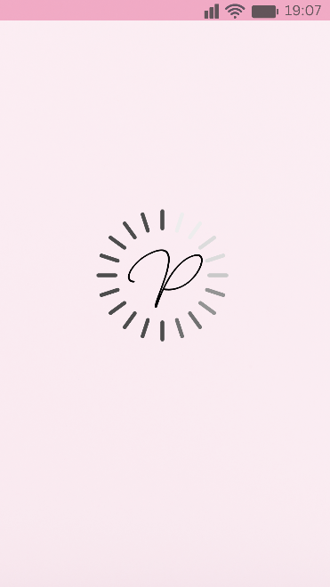 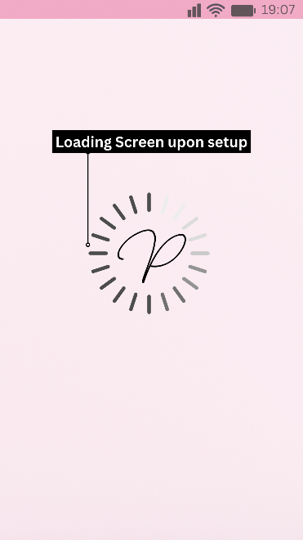

**Loading Screen –** This what will happen when you open up the app to let you know the app is initializing.

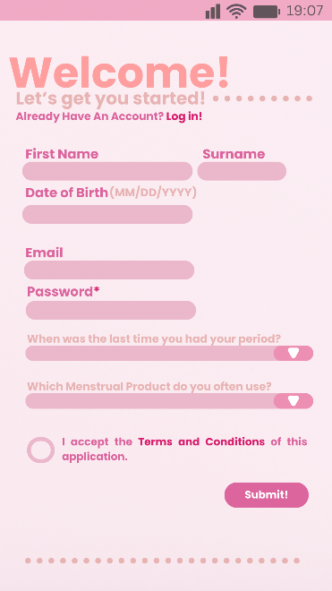 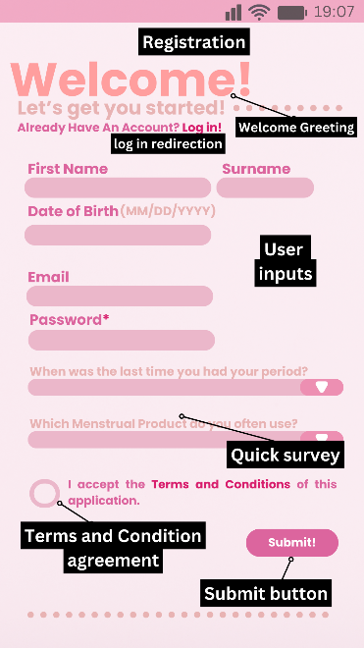

**Registration –** This shows how the registration work. A simple user inputs and agreeing to the terms and condition, which will then proceed to the promotion screen.

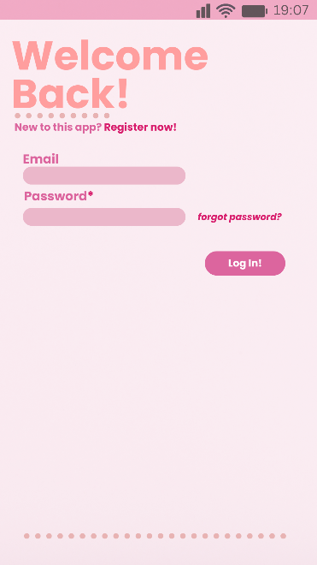 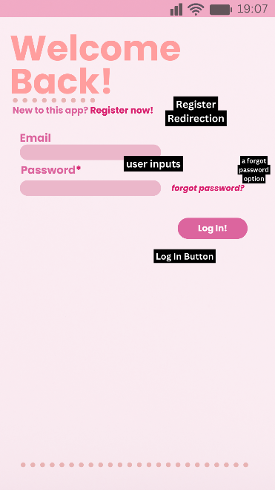

**Log In –** This displays the log in when you press the log in redirection and vice versa when clicking the “register now!”. Just as the registration screen, but you input the authorization inputs instead of your name, birthday, and doing the survey.

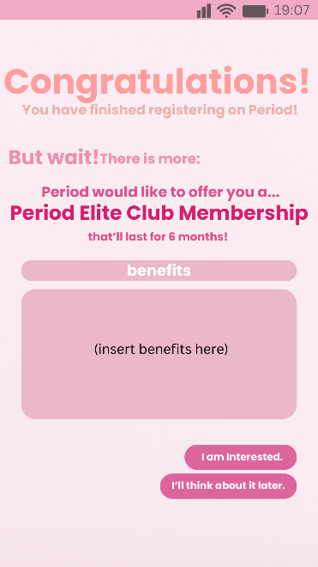 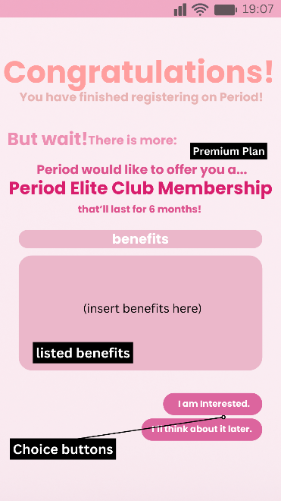

**Promotion Screen –** After registering, you will be redirected to an offer. This where you can accept or not accept the offer. If you chose “I am interested”, you will be redirected to the **shop.** However, pressing “I’ll think about it later” redirects you to **home.**

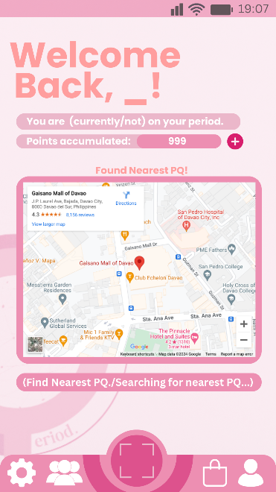 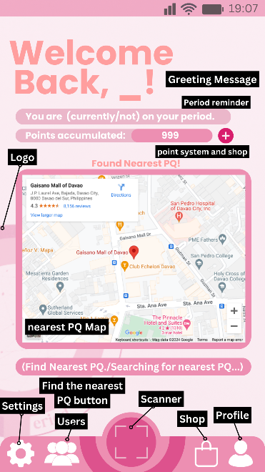

**Default Setup / Home –** Here will display your status and points. You’re able to find the nearest-installed PQ (Vending Machine). You can press the icons below to redirect you to that location.

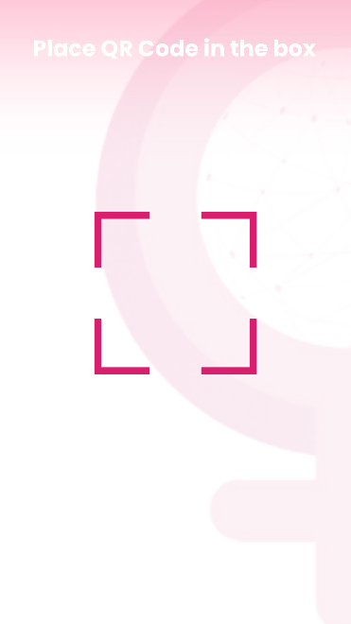 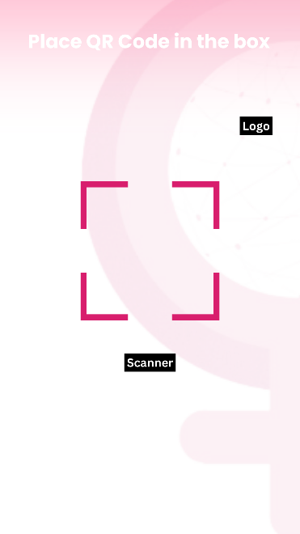

**The QR function –** When pressing the **scanner**, you are redirected to this screen where you are able to place a PQ QR code. This scanner can only identify PQs and is invalid if scanned to a non-PQ QR.

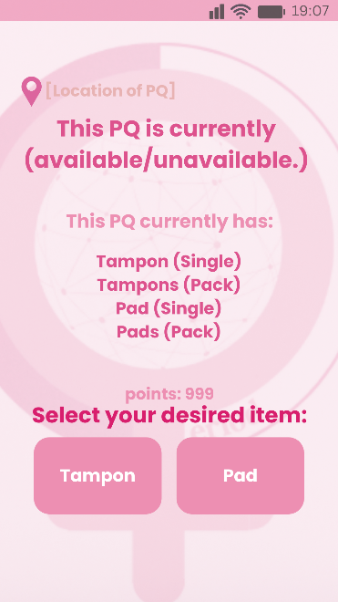 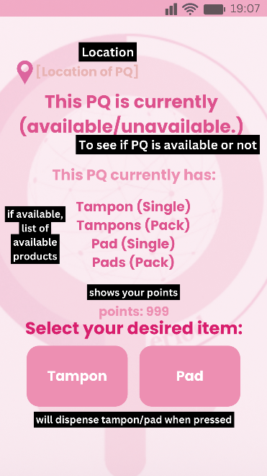

**Authentication for PQ –** After scanning a PQ QR, you will be redirected to this screen where it’ll display the location, the status, and the available items in the PQ. After that, you can see at the bottom where you can pick either tampon or pad to dispense. Using PQ requires 10-30 points and you can gain them daily (60 pts.).

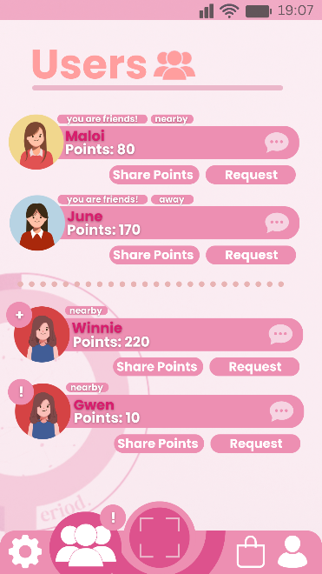 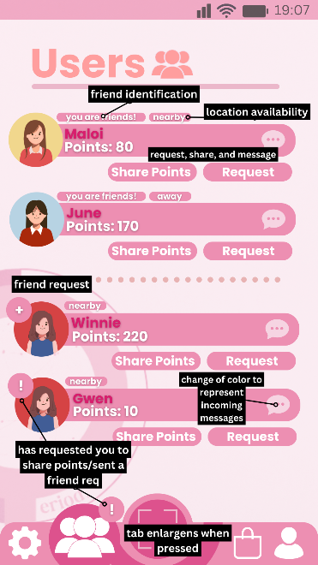

**Users –** In Period, there is an option to befriend other Period users. The users displayed will have their name, points, and their location status. Here you can share and request points with other users.

**Store –** This tab in Period displays the Premium membership and an option to inquire a PQ in your establishment. Below, shows points you can buy so you can use PQ.

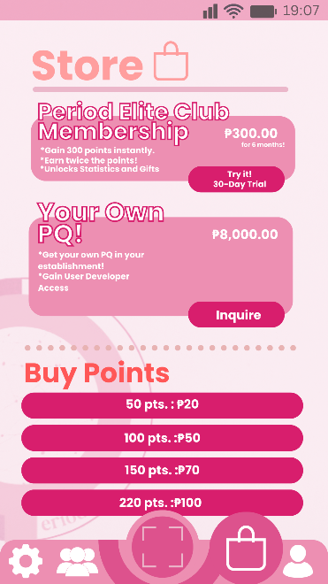 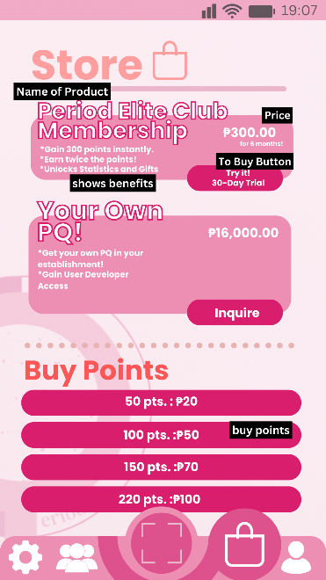

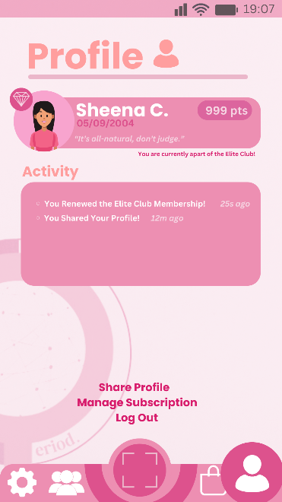 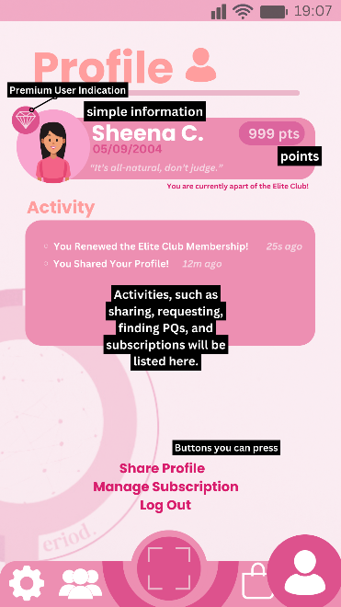

**Profile –** This where your profile shows. This displays your name, your birthdate, points, and activities. Here you can share your profile, manage your subscription, and log out.

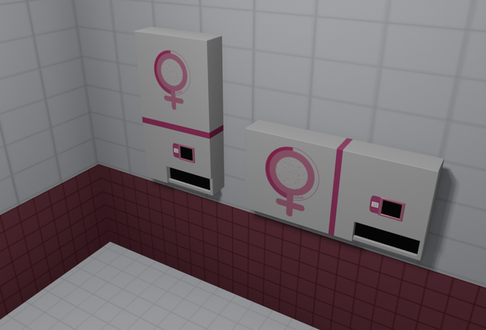

**PQ –** PQ stands for “Project: Quality” where the vending machine that dispenses tampons and pads require authorization instead of coins.

**Design Alternatives**



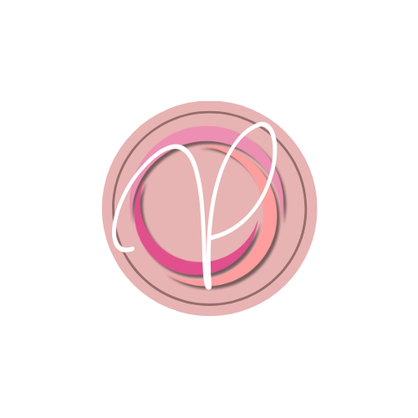 

**Supposed App Logos** – The app logo would’ve been different from the actual Period logo, but all of them were scrapped due to being too different from the overall design. Instead, we used the same typeface P to be the logo for the loading setup.

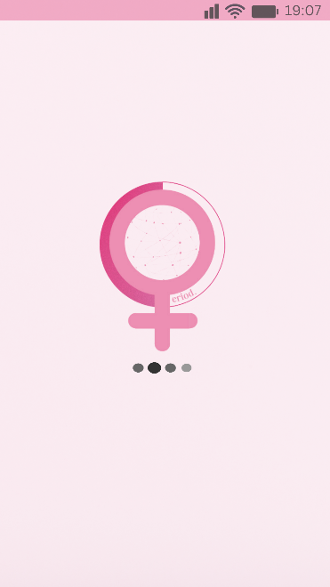 

**Logo On Loading Screen** – Supposedly, the Period logo was going to be the center, however it was scrapped because it didn’t capture a minimalistic look for the loading screen.